Rectangle
# Source: AI Source: Provided by: [Data Path: Persons Table -> ID Column: 1, Name_En Column: Motasem Essam] -> From: [ChatGPT] on [7/25/2026]
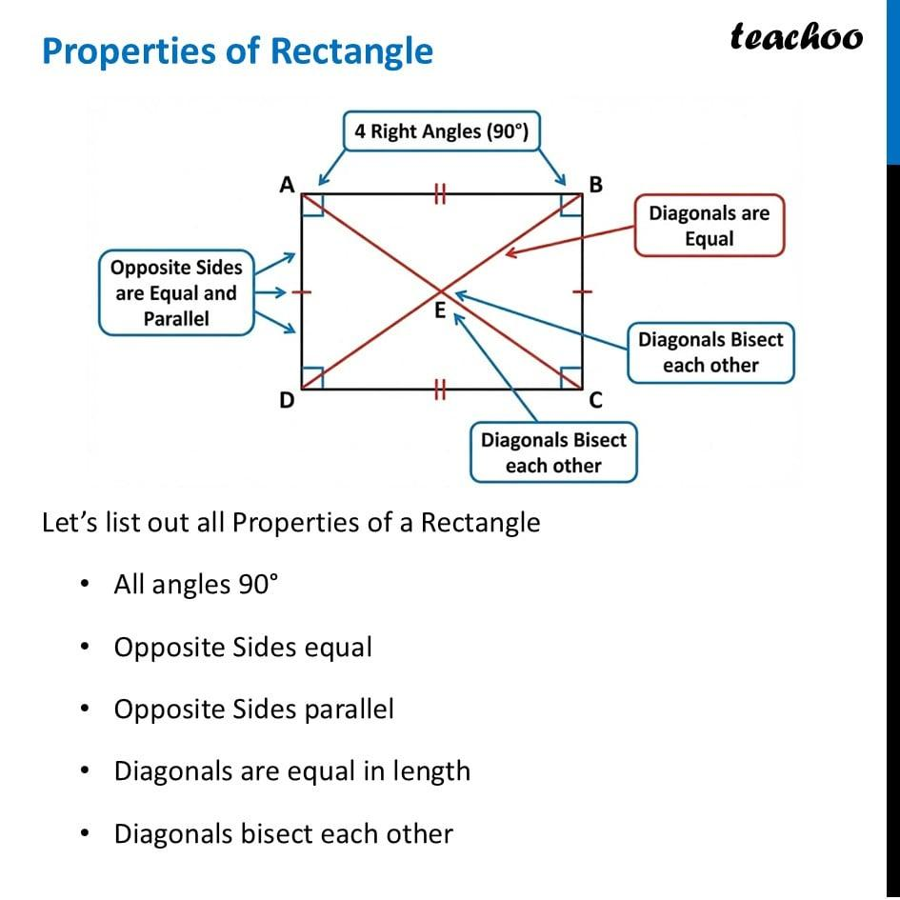
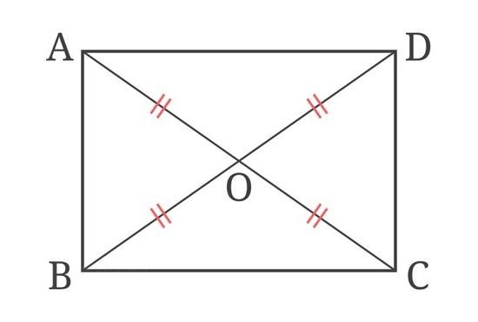
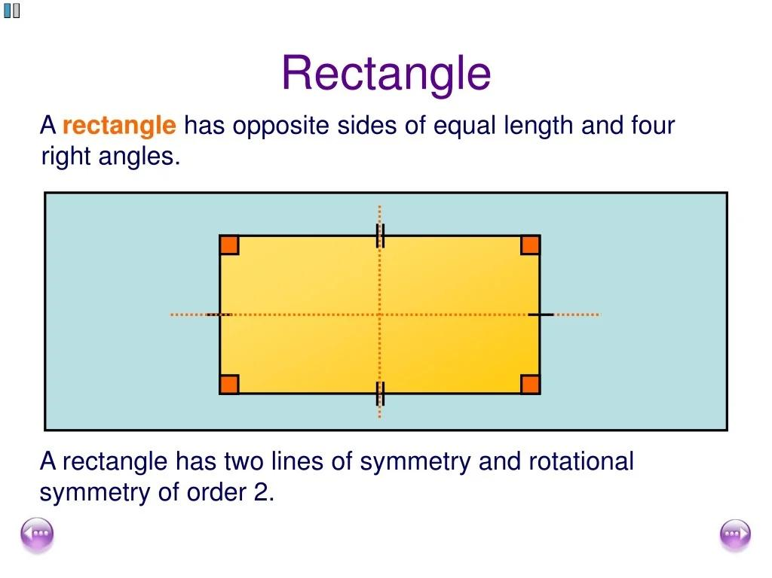
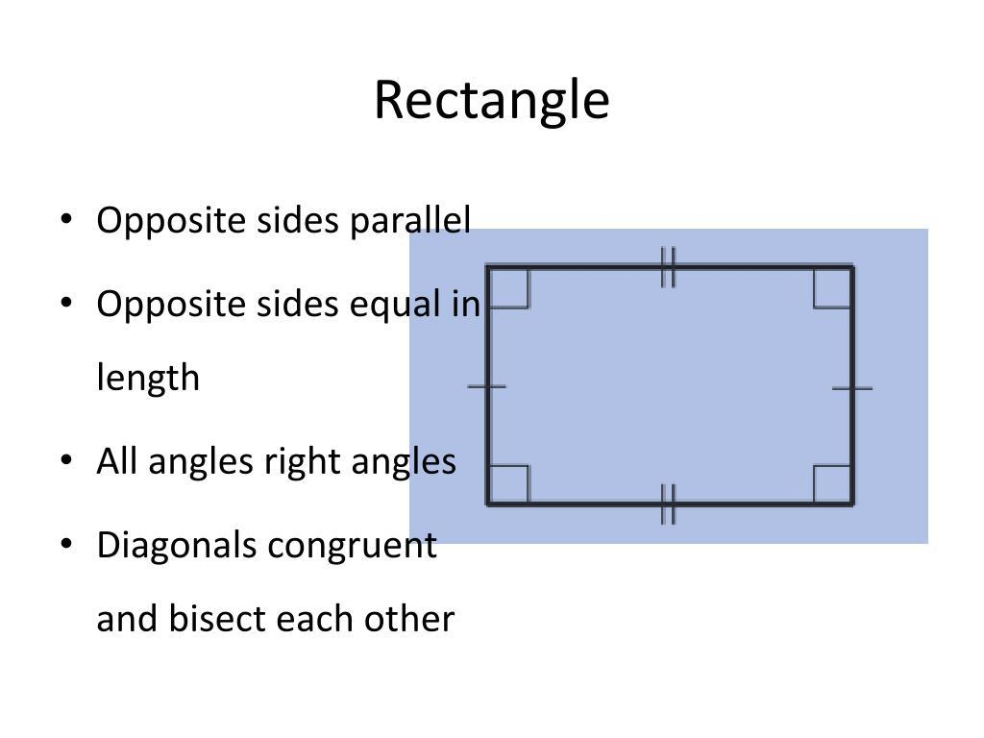
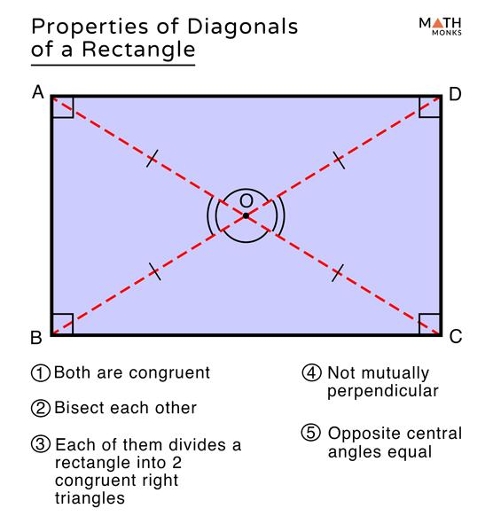
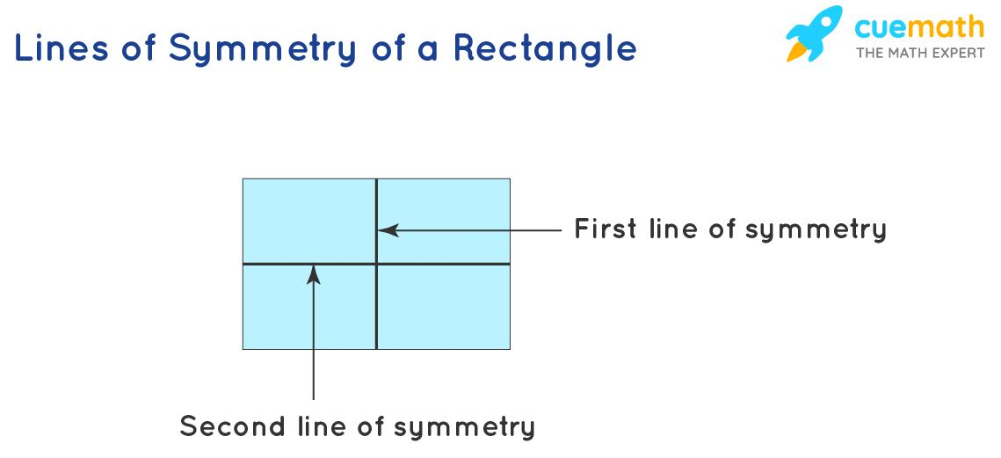

Definition
# Source: AI Source: Provided by: [Data Path: Persons Table -> ID Column: 1, Name_En Column: Motasem Essam] -> From: [ChatGPT] on [7/25/2026]
A rectangle is a quadrilateral with four right angles.
For rectangle $ABCD$:
$$∠A=∠B=∠C=∠D={90}^{∘}$$
Because the interior angles of a quadrilateral sum to ${360}^{∘}$, four right angles satisfy:
$$4\left({90}^{∘}\right)={360}^{∘}$$
A rectangle is also a special type of parallelogram.

Purpose
# Source: AI Source: Provided by: [Data Path: Persons Table -> ID Column: 1, Name_En Column: Motasem Essam] -> From: [ChatGPT] on [7/25/2026]
Rectangles are used to:
- Study quadrilaterals with four right angles.
- Calculate perimeter and area.
- Study relationships between opposite sides.
- Study diagonal properties.
- Understand special cases of parallelograms.
- Model many common shapes in architecture, engineering, and design.

Fundamental Elements
# Source: AI Source: Provided by: [Data Path: Persons Table -> ID Column: 1, Name_En Column: Motasem Essam] -> From: [ChatGPT] on [7/25/2026]
Consider rectangle $ABCD$.
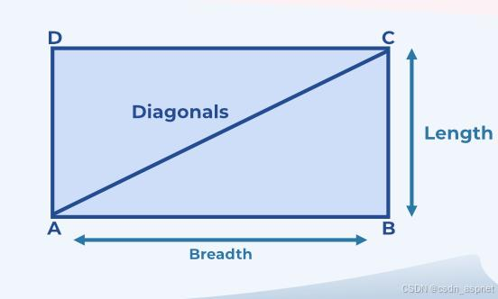
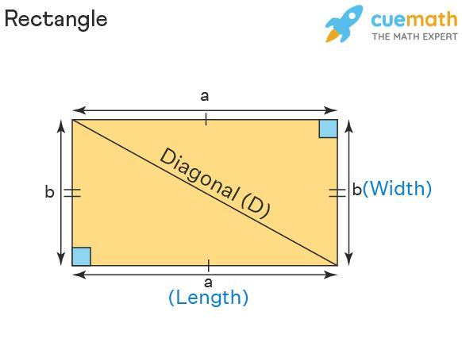
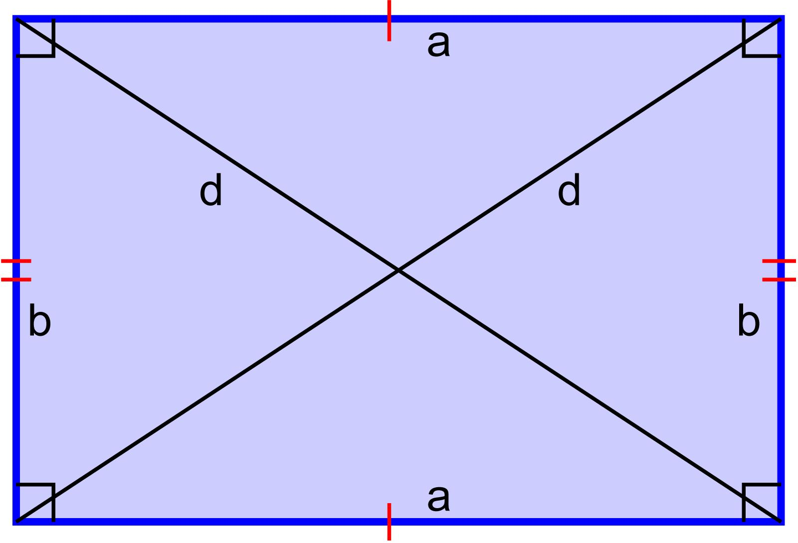
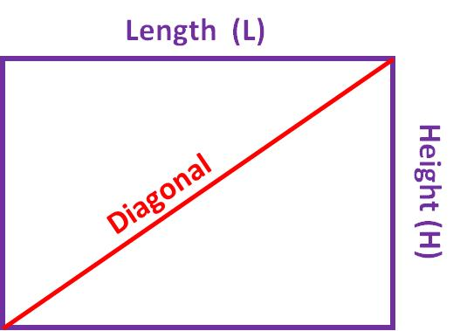
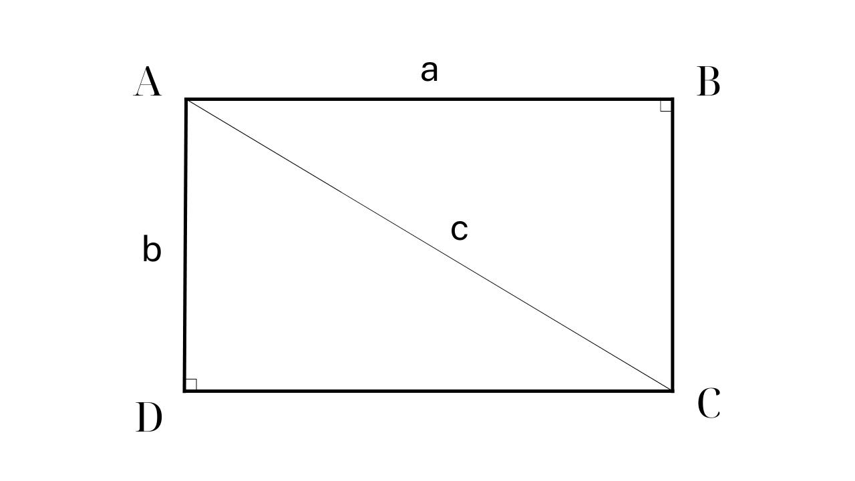
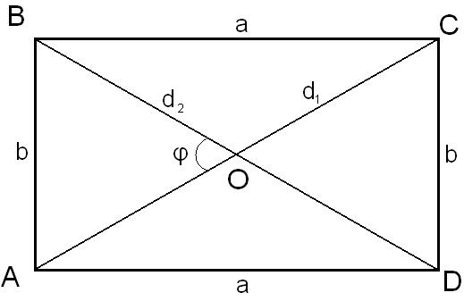

1. Sides
# Source: AI Source: Provided by: [Data Path: Persons Table -> ID Column: 1, Name_En Column: Motasem Essam] -> From: [ChatGPT] on [7/25/2026]
The four sides are:
$$\overset{‾}{AB}, \overset{‾}{BC}, \overset{‾}{CD}, \overset{‾}{DA}$$
Opposite sides are congruent:
$$\boxed{AB=CD} \\ \boxed{BC=DA}$$

2. Vertices
# Source: AI Source: Provided by: [Data Path: Persons Table -> ID Column: 1, Name_En Column: Motasem Essam] -> From: [ChatGPT] on [7/25/2026]
The four vertices are:
$$A, B, C, D$$

3. Interior Angles
# Source: AI Source: Provided by: [Data Path: Persons Table -> ID Column: 1, Name_En Column: Motasem Essam] -> From: [ChatGPT] on [7/25/2026]
Every interior angle is:
$$\boxed{{90}^{∘}}$$

4. Diagonals
# Source: AI Source: Provided by: [Data Path: Persons Table -> ID Column: 1, Name_En Column: Motasem Essam] -> From: [ChatGPT] on [7/25/2026]
The diagonals are:
$$\overset{‾}{AC}$$
and
$$\overset{‾}{BD}$$

5. Length and Width
# Source: AI Source: Provided by: [Data Path: Persons Table -> ID Column: 1, Name_En Column: Motasem Essam] -> From: [ChatGPT] on [7/25/2026]
The longer dimension is commonly called the length $l$, and the shorter dimension the width $w$.

Defining Properties
# Source: AI Source: Provided by: [Data Path: Persons Table -> ID Column: 1, Name_En Column: Motasem Essam] -> From: [ChatGPT] on [7/25/2026]
The fundamental defining property of a rectangle is:
$$\boxed{\text{Four right angles}}$$
A rectangle also has the following properties:
- Opposite sides are parallel.
- Opposite sides are congruent.
- Diagonals are congruent.
- Diagonals bisect each other.
Thus:
$$AB∥CD$$
and
$$AD∥BC$$

Rectangle as a Parallelogram
# Source: AI Source: Provided by: [Data Path: Persons Table -> ID Column: 1, Name_En Column: Motasem Essam] -> From: [ChatGPT] on [7/25/2026]
Every rectangle is a parallelogram because it has two pairs of parallel opposite sides.
$$\boxed{\text{Rectangle}⊂\text{Parallelogram}}$$
However, not every parallelogram is a rectangle.
A general parallelogram does not necessarily have four right angles.

Perimeter
# Source: AI Source: Provided by: [Data Path: Persons Table -> ID Column: 1, Name_En Column: Motasem Essam] -> From: [ChatGPT] on [7/25/2026]
The perimeter of a rectangle is:
$$\boxed{P=2l+2w}$$
or:
$$\boxed{P=2\left(l+w\right)}$$
Example
A rectangle has:
$$l=12\text{ cm}$$
and
$$w=5\text{ cm}$$
Then:
$$P=2\left(12+5\right) \\ P=2\left(17\right) \\ \boxed{P=34\text{ cm}}$$

Area
# Source: AI Source: Provided by: [Data Path: Persons Table -> ID Column: 1, Name_En Column: Motasem Essam] -> From: [ChatGPT] on [7/25/2026]
The area of a rectangle is:
$$\boxed{A=lw}$$
Example
If:
$$l=12\text{ cm}, w=5\text{ cm}$$
then:
$$A=12\left(5\right) \\ \boxed{A=60{\text{ cm}}^{2}}$$

Diagonals
# Source: AI Source: Provided by: [Data Path: Persons Table -> ID Column: 1, Name_En Column: Motasem Essam] -> From: [ChatGPT] on [7/25/2026]
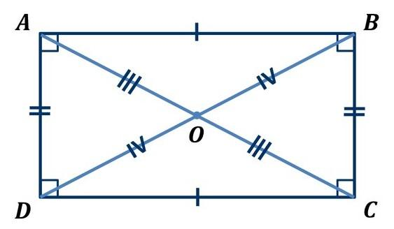
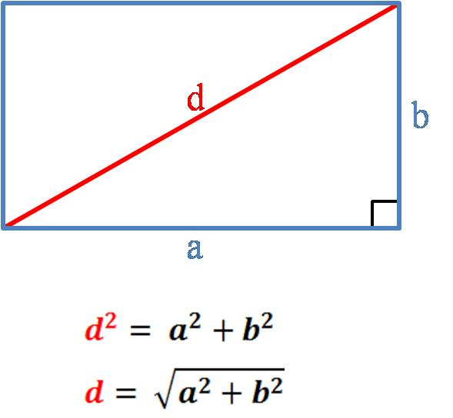
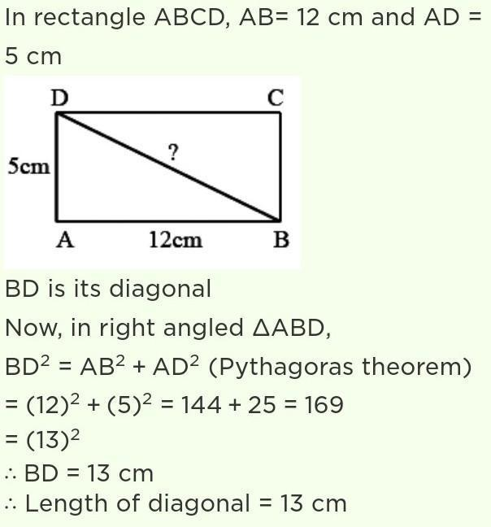
A rectangle has two diagonals:
$$\overset{‾}{AC}$$
and
$$\overset{‾}{BD}$$
They have two important properties.
Congruent Diagonals
$$\boxed{AC=BD}$$
Diagonals Bisect Each Other
If the diagonals intersect at $O$:
$$\boxed{AO=OC}$$
and
$$\boxed{BO=OD}$$
However, the diagonals of a general rectangle are not necessarily perpendicular.
They are perpendicular only in the special case where the rectangle is a square.

Diagonal Length
# Source: AI Source: Provided by: [Data Path: Persons Table -> ID Column: 1, Name_En Column: Motasem Essam] -> From: [ChatGPT] on [7/25/2026]
The diagonal of a rectangle can be found using the Pythagorean Theorem:
$$\boxed{d=\sqrt{l^{2}+w^{2}}}$$
Example
Suppose:
$$l=6\text{ cm}$$
and:
$$w=8\text{ cm}$$
Then:
$$d=\sqrt{6^{2}+8^{2}} \\ d=\sqrt{36+64} \\ d=\sqrt{100} \\ \boxed{d=10\text{ cm}}$$

Relationship Between Area and Perimeter

For a rectangle:
$$A=lw$$
while:
$$P=2\left(l+w\right)$$
The area measures the surface enclosed by the rectangle, while the perimeter measures the length around its boundary.
For example, a $10×4$rectangle has:
$$A=40$$
and:
$$P=28$$
These quantities measure different things and use different units.

Symmetry
# Source: AI Source: Provided by: [Data Path: Persons Table -> ID Column: 1, Name_En Column: Motasem Essam] -> From: [ChatGPT] on [7/25/2026]
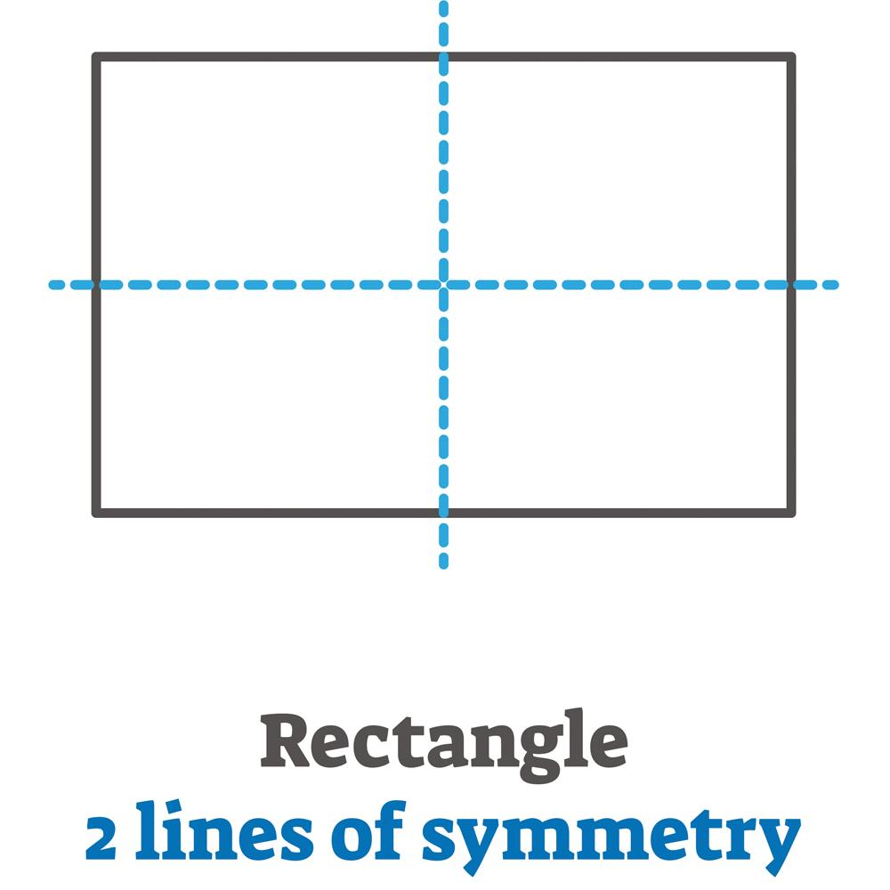
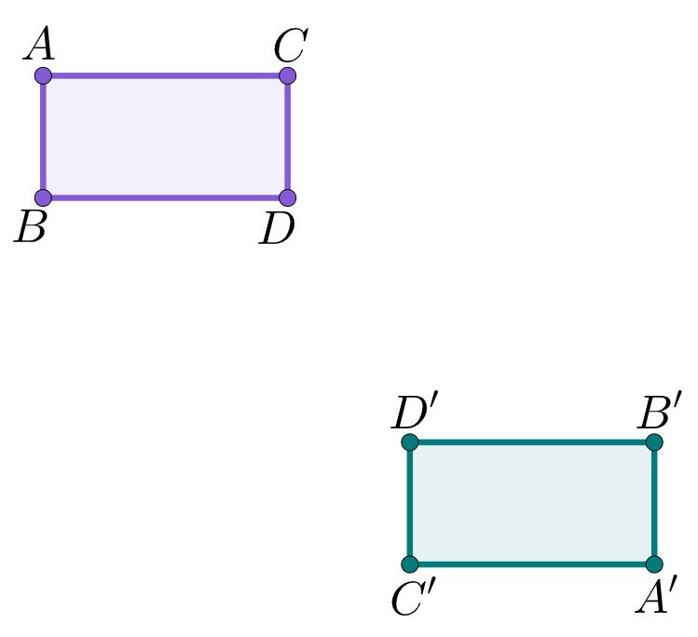
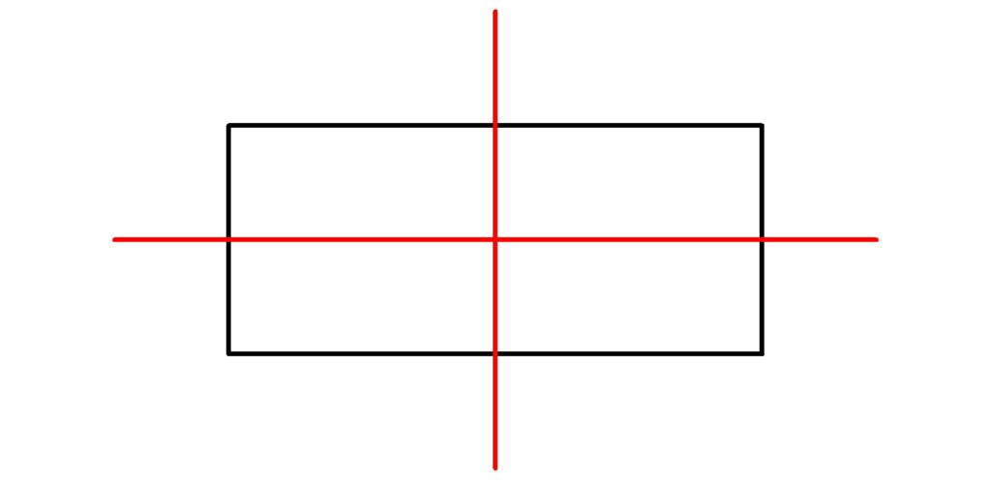
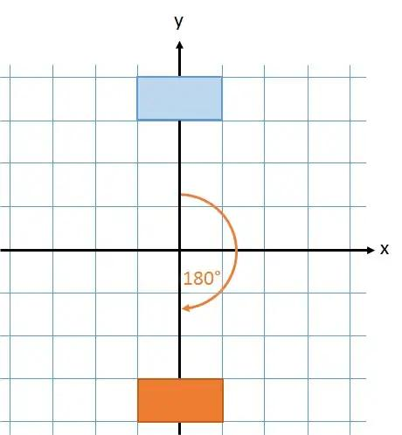

Lines of Symmetry
# Source: AI Source: Provided by: [Data Path: Persons Table -> ID Column: 1, Name_En Column: Motasem Essam] -> From: [ChatGPT] on [7/25/2026]
A non-square rectangle has:
$$\boxed{2}$$
lines of symmetry.
They pass through the midpoints of opposite sides.
A square is a special rectangle and has 4 lines of symmetry.

Rotational Symmetry
# Source: AI Source: Provided by: [Data Path: Persons Table -> ID Column: 1, Name_En Column: Motasem Essam] -> From: [ChatGPT] on [7/25/2026]
A rectangle has rotational symmetry of order:
$$\boxed{2}$$
It maps onto itself after:
$${180}^{∘}$$
and:
$${360}^{∘}$$
The smallest non-zero angle of rotational symmetry is:
$$\boxed{{180}^{∘}}$$

Interior Angles
# Source: AI Source: Provided by: [Data Path: Persons Table -> ID Column: 1, Name_En Column: Motasem Essam] -> From: [ChatGPT] on [7/25/2026]
Every rectangle has four right angles:
$$\boxed{{90}^{∘}}$$
Therefore:
$$∠A+∠B+∠C+∠D={90}^{∘}+{90}^{∘}+{90}^{∘}+{90}^{∘} \\ \boxed{{360}^{∘}}$$

Opposite and Consecutive Angles
# Source: AI Source: Provided by: [Data Path: Persons Table -> ID Column: 1, Name_En Column: Motasem Essam] -> From: [ChatGPT] on [7/25/2026]
Because all four angles are ${90}^{∘}$:
Opposite angles
$$∠A=∠C \\ ∠B=∠D$$
Consecutive angles
Every pair of consecutive angles is supplementary:
$${90}^{∘}+{90}^{∘}={180}^{∘}$$

Examples
# Source: AI Source: Provided by: [Data Path: Persons Table -> ID Column: 1, Name_En Column: Motasem Essam] -> From: [ChatGPT] on [7/25/2026]
Example 1: Find the Area
A rectangle has length $15$m and width $4$m.
$$A=lw \\ A=15\left(4\right) \\ \boxed{A=60{\text{ m}}^{2}}$$

Example 2: Find the Perimeter
A rectangle has length $20$cm and width $7$cm.
$$P=2\left(l+w\right) \\ P=2\left(20+7\right) \\ P=54 \\ \boxed{P=54\text{ cm}}$$

Example 3: Find the Missing Side
A rectangle has area:
$$A=72{\text{ cm}}^{2}$$
and length:
$$l=12\text{ cm}$$
Using:
$$A=lw$$
we get:
$$72=12w \\ w=6$$
Therefore:
$$\boxed{w=6\text{ cm}}$$

Example 4: Find the Diagonal
A rectangle has length $9$cm and width $12$cm.
$$d=\sqrt{l^{2}+w^{2}} \\ d=\sqrt{9^{2}+{12}^{2}} \\ d=\sqrt{81+144} \\ d=\sqrt{225} \\ \boxed{d=15\text{ cm}}$$

Rectangle and Square
# Source: AI Source: Provided by: [Data Path: Persons Table -> ID Column: 1, Name_En Column: Motasem Essam] -> From: [ChatGPT] on [7/25/2026]
A square is a special type of rectangle.
Both have:
- Four right angles.
- Opposite sides parallel.
- Opposite sides equal.
- Congruent diagonals.
- Diagonals that bisect each other.
The difference is:
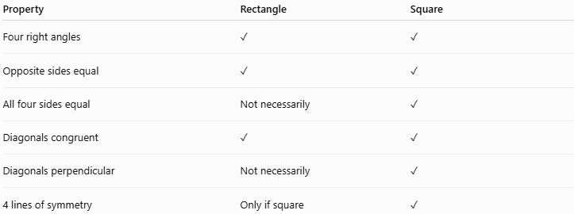
Property | Rectangle | Square
Four right angles | ✓ | ✓
Opposite sides equal | ✓ | ✓
All four sides equal | Not necessarily | ✓
Diagonals congruent | ✓ | ✓
Diagonals perpendicular | Not necessarily | ✓
4 lines of symmetry | Only if square | ✓
Therefore:
$$\boxed{\text{Every square is a rectangle}}$$
but:
$$\boxed{\text{Not every rectangle is a square}}$$

Rectangle and Rhombus
# Source: AI Source: Provided by: [Data Path: Persons Table -> ID Column: 1, Name_En Column: Motasem Essam] -> From: [ChatGPT] on [7/25/2026]
A rectangle and a rhombus are both special parallelograms.
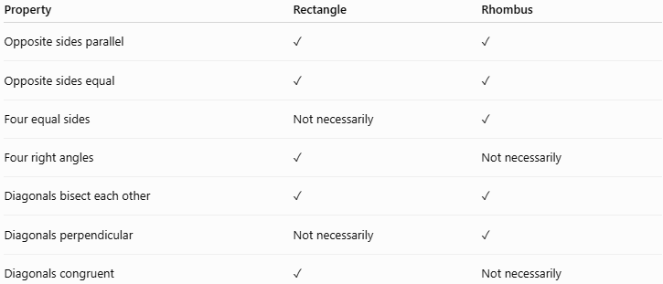
Property | Rectangle | Rhombus
Opposite sides parallel | ✓ | ✓
Opposite sides equal | ✓ | ✓
Four equal sides | Not necessarily | ✓
Four right angles | ✓ | Not necessarily
Diagonals bisect each other | ✓ | ✓
Diagonals perpendicular | Not necessarily | ✓
Diagonals congruent | ✓ | Not necessarily
A quadrilateral that is both a rectangle and a rhombus is a:
$$\boxed{\text{Square}}$$

Rectangle and Parallelogram
# Source: AI Source: Provided by: [Data Path: Persons Table -> ID Column: 1, Name_En Column: Motasem Essam] -> From: [ChatGPT] on [7/25/2026]
A rectangle inherits several properties from the parallelogram.
Parallelogram
- Opposite sides are parallel.
- Opposite sides are congruent.
- Opposite angles are congruent.
- Diagonals bisect each other.
Rectangle
It has all of those properties plus four right angles.
Therefore:
$$\boxed{\text{Rectangle}=\text{Parallelogram with four right angles}}$$

Coordinate Geometry
# Source: AI Source: Provided by: [Data Path: Persons Table -> ID Column: 1, Name_En Column: Motasem Essam] -> From: [ChatGPT] on [7/25/2026]
A rectangle can be represented conveniently on the coordinate plane.
For example, consider:
$$A\left(0 , 0\right), B\left(l , 0\right), C\left(l , w\right), D\left(0 , w\right)$$
Then:
$$AB=l$$
and:
$$BC=w$$
The area is:
$$A=lw$$
The diagonal $AC$has length:
$$AC=\sqrt{{\left(l-0\right)}^{2}+{\left(w-0\right)}^{2}}$$
Therefore:
$$\boxed{AC=\sqrt{l^{2}+w^{2}}}$$

Important Theorems and Properties
# Source: AI Source: Provided by: [Data Path: Persons Table -> ID Column: 1, Name_En Column: Motasem Essam] -> From: [ChatGPT] on [7/25/2026]
Rectangle Diagonal Theorem
The diagonals of a rectangle are congruent.
$$\boxed{AC=BD}$$
Parallelogram Diagonal Property
Because a rectangle is a parallelogram, its diagonals bisect each other.
If they intersect at $O$:
$$\boxed{AO=OC} \\ \boxed{BO=OD}$$
Right-Angle Property
Every interior angle is:
$$\boxed{{90}^{∘}}$$

Real-World Applications
# Source: AI Source: Provided by: [Data Path: Persons Table -> ID Column: 1, Name_En Column: Motasem Essam] -> From: [ChatGPT] on [7/25/2026]
Rectangles are among the most commonly used geometric shapes.
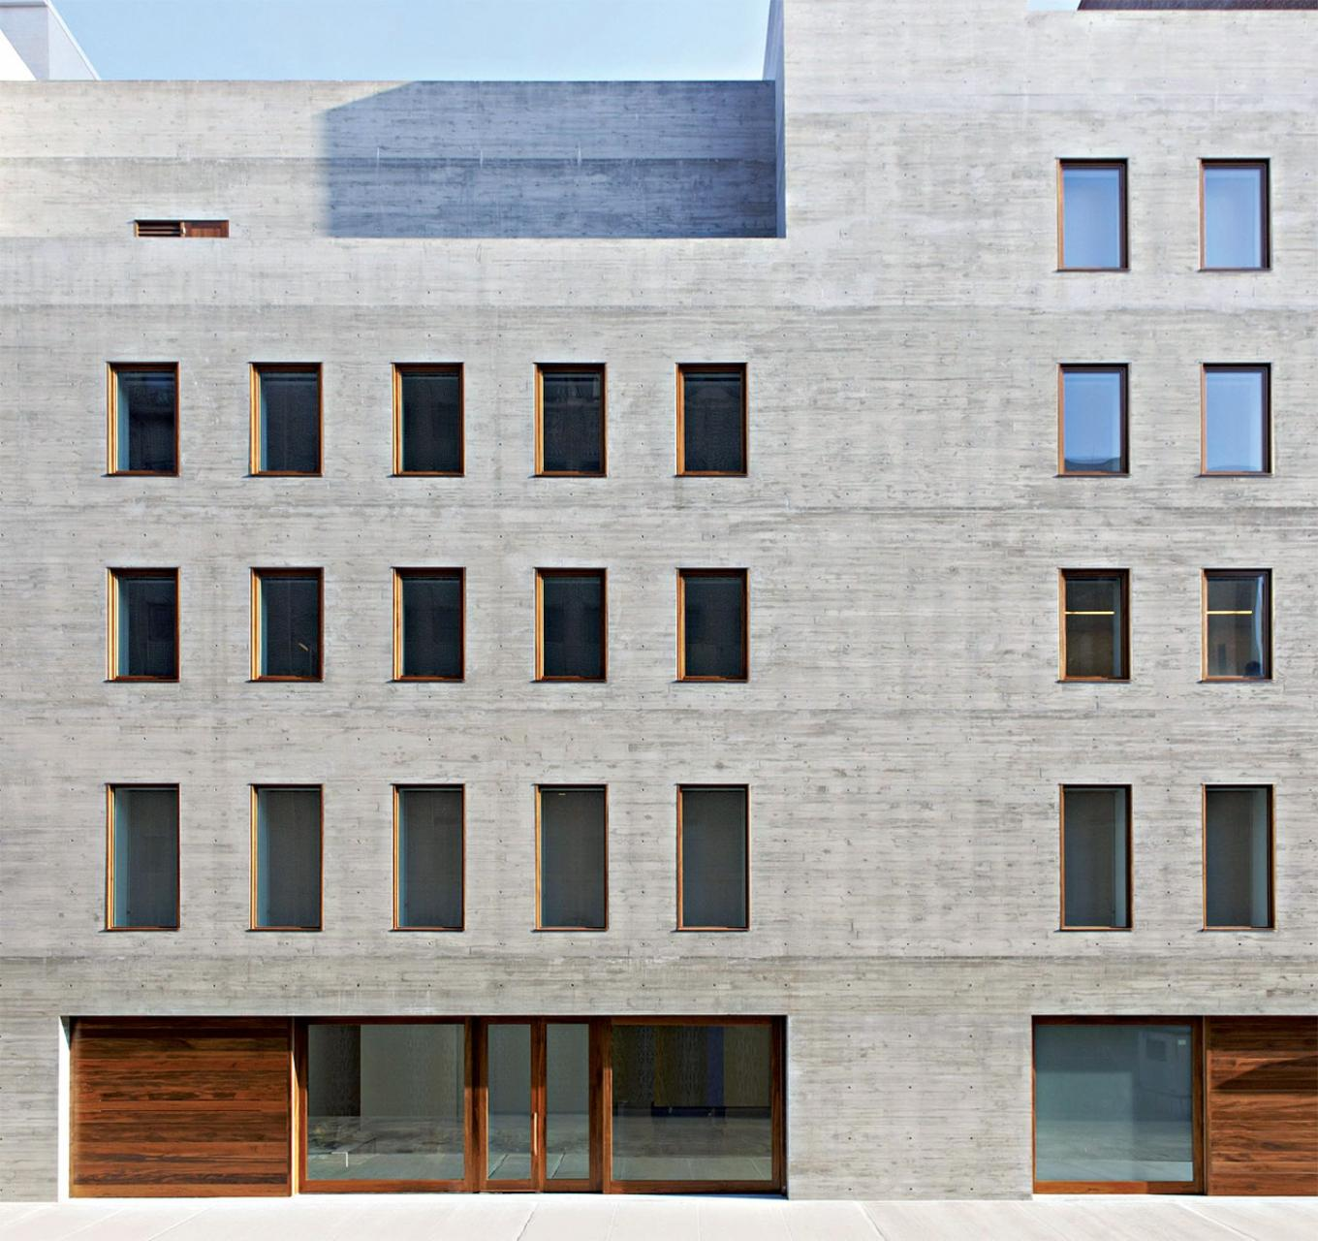
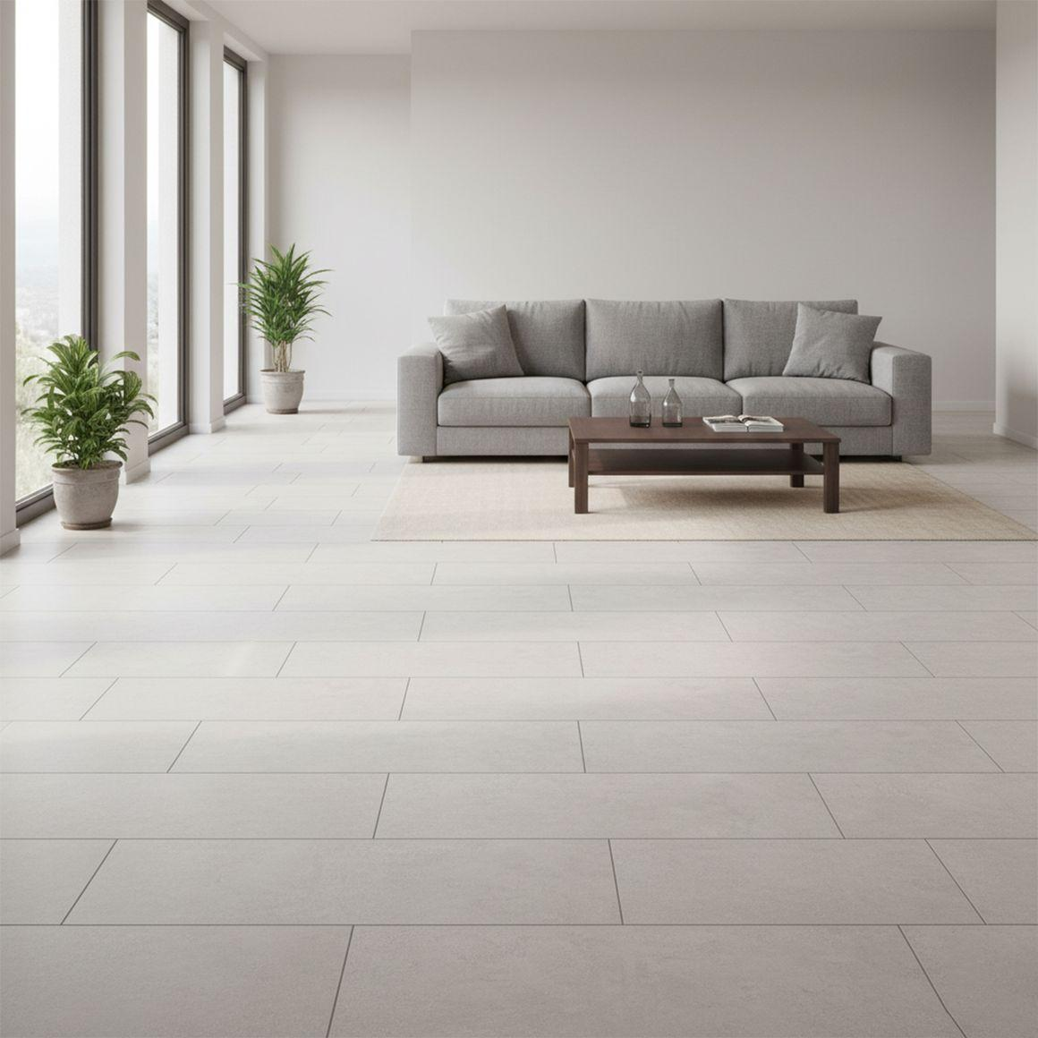

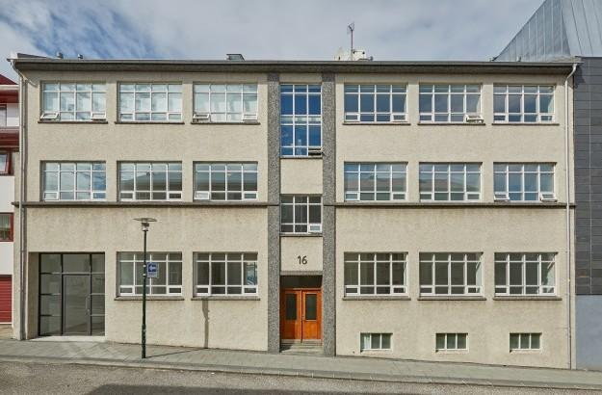
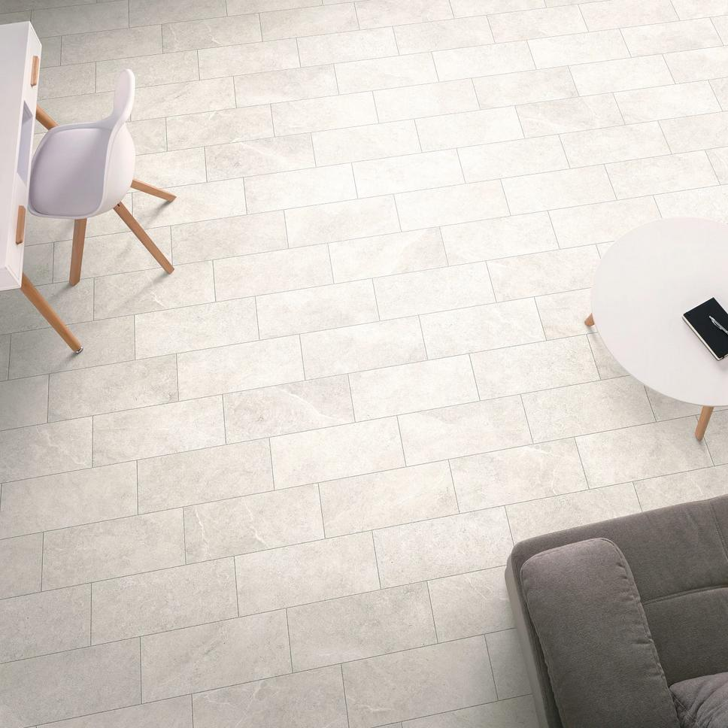
They are used in:
- Doors and windows.
- Rooms and buildings.
- Books and paper.
- Computer and television screens.
- Smartphones and tablets.
- Floor tiles.
- Tables and desks.
- Engineering drawings.
- Packaging and boxes.
- Sports fields and courts.

Advantages
# Source: AI Source: Provided by: [Data Path: Persons Table -> ID Column: 1, Name_En Column: Motasem Essam] -> From: [ChatGPT] on [7/25/2026]
- Simple formulas for area and perimeter.
- Four right angles make construction and measurement convenient.
- Diagonal properties are easy to apply.
- Common in architecture and engineering.
- Easy to represent using coordinates.
- Provides a useful special case of a parallelogram.

Limitations
# Source: AI Source: Provided by: [Data Path: Persons Table -> ID Column: 1, Name_En Column: Motasem Essam] -> From: [ChatGPT] on [7/25/2026]
- Not every four-sided figure is a rectangle.
- A general rectangle does not necessarily have four equal sides.
- Its diagonals are not generally perpendicular.
- A drawing that appears rectangular does not constitute a mathematical proof that it is a rectangle.

Comparison with Related Quadrilaterals
# Source: AI Source: Provided by: [Data Path: Persons Table -> ID Column: 1, Name_En Column: Motasem Essam] -> From: [ChatGPT] on [7/25/2026]
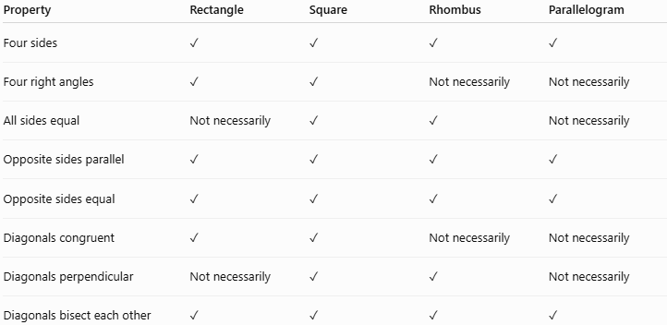
Property | Rectangle | Square | Rhombus | Parallelogram
Four sides | ✓ | ✓ | ✓ | ✓
Four right angles | ✓ | ✓ | Not necessarily | Not necessarily
All sides equal | Not necessarily | ✓ | ✓ | Not necessarily
Opposite sides parallel | ✓ | ✓ | ✓ | ✓
Opposite sides equal | ✓ | ✓ | ✓ | ✓
Diagonals congruent | ✓ | ✓ | Not necessarily | Not necessarily
Diagonals perpendicular | Not necessarily | ✓ | ✓ | Not necessarily
Diagonals bisect each other | ✓ | ✓ | ✓ | ✓

Key Points
# Source: AI Source: Provided by: [Data Path: Persons Table -> ID Column: 1, Name_En Column: Motasem Essam] -> From: [ChatGPT] on [7/25/2026]
- A rectangle is a quadrilateral with four right angles.
- Every interior angle measures:
$$\boxed{{90}^{∘}}$$
- Opposite sides are:
  - Parallel.
  - Congruent.
- Perimeter:
$$\boxed{P=2\left(l+w\right)}$$
- Area:
$$\boxed{A=lw}$$
- Diagonal:
$$\boxed{d=\sqrt{l^{2}+w^{2}}}$$
- The diagonals are congruent:
$$\boxed{AC=BD}$$
- The diagonals bisect each other.
- A rectangle has 2 lines of symmetry unless it is a square.
- A rectangle has rotational symmetry of order 2.
- Every square is a rectangle, but not every rectangle is a square.

Conclusion
# Source: AI Source: Provided by: [Data Path: Persons Table -> ID Column: 1, Name_En Column: Motasem Essam] -> From: [ChatGPT] on [7/25/2026]
A rectangle is a fundamental quadrilateral characterized by its four right angles. It is a special type of parallelogram with opposite sides parallel and congruent. Its diagonals are congruent and bisect each other, while its area, perimeter, and diagonal can be calculated using simple formulas. The rectangle is especially important because the square is a special rectangle, making it a central concept in the classification of quadrilaterals.

